Exercise 2: Verifying Interactions
Scenario: You need to ensure that a method is called with specific arguments.
ExternalApi.java:
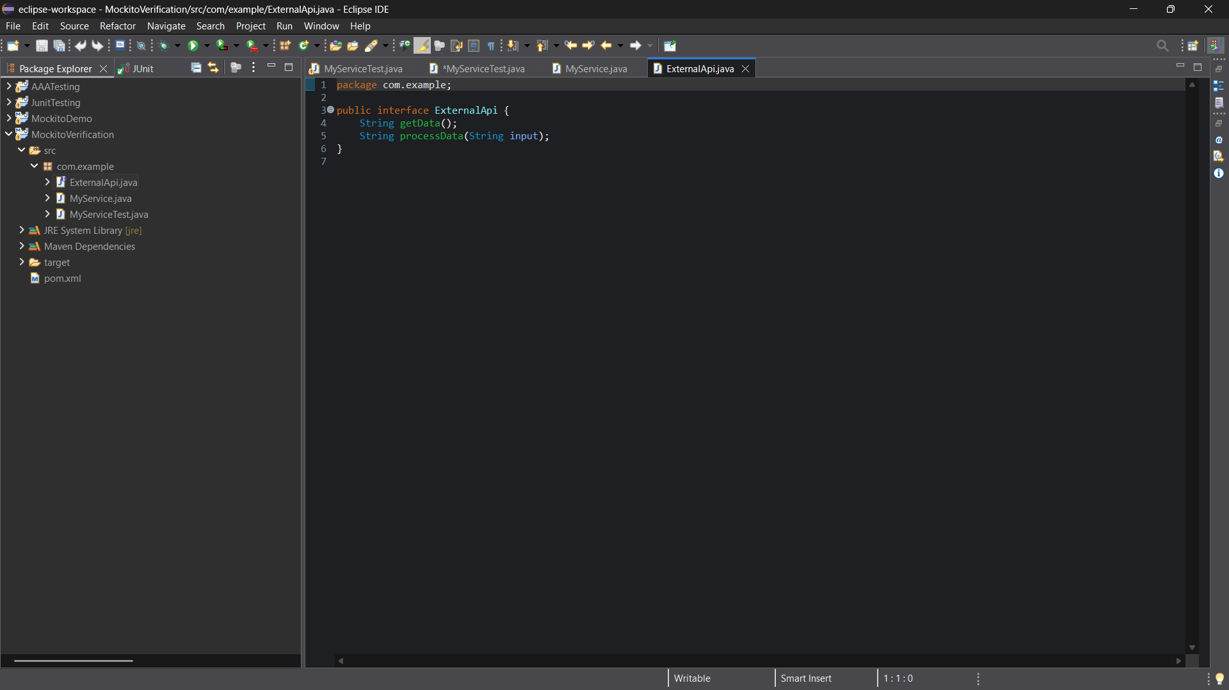
MyService.java:
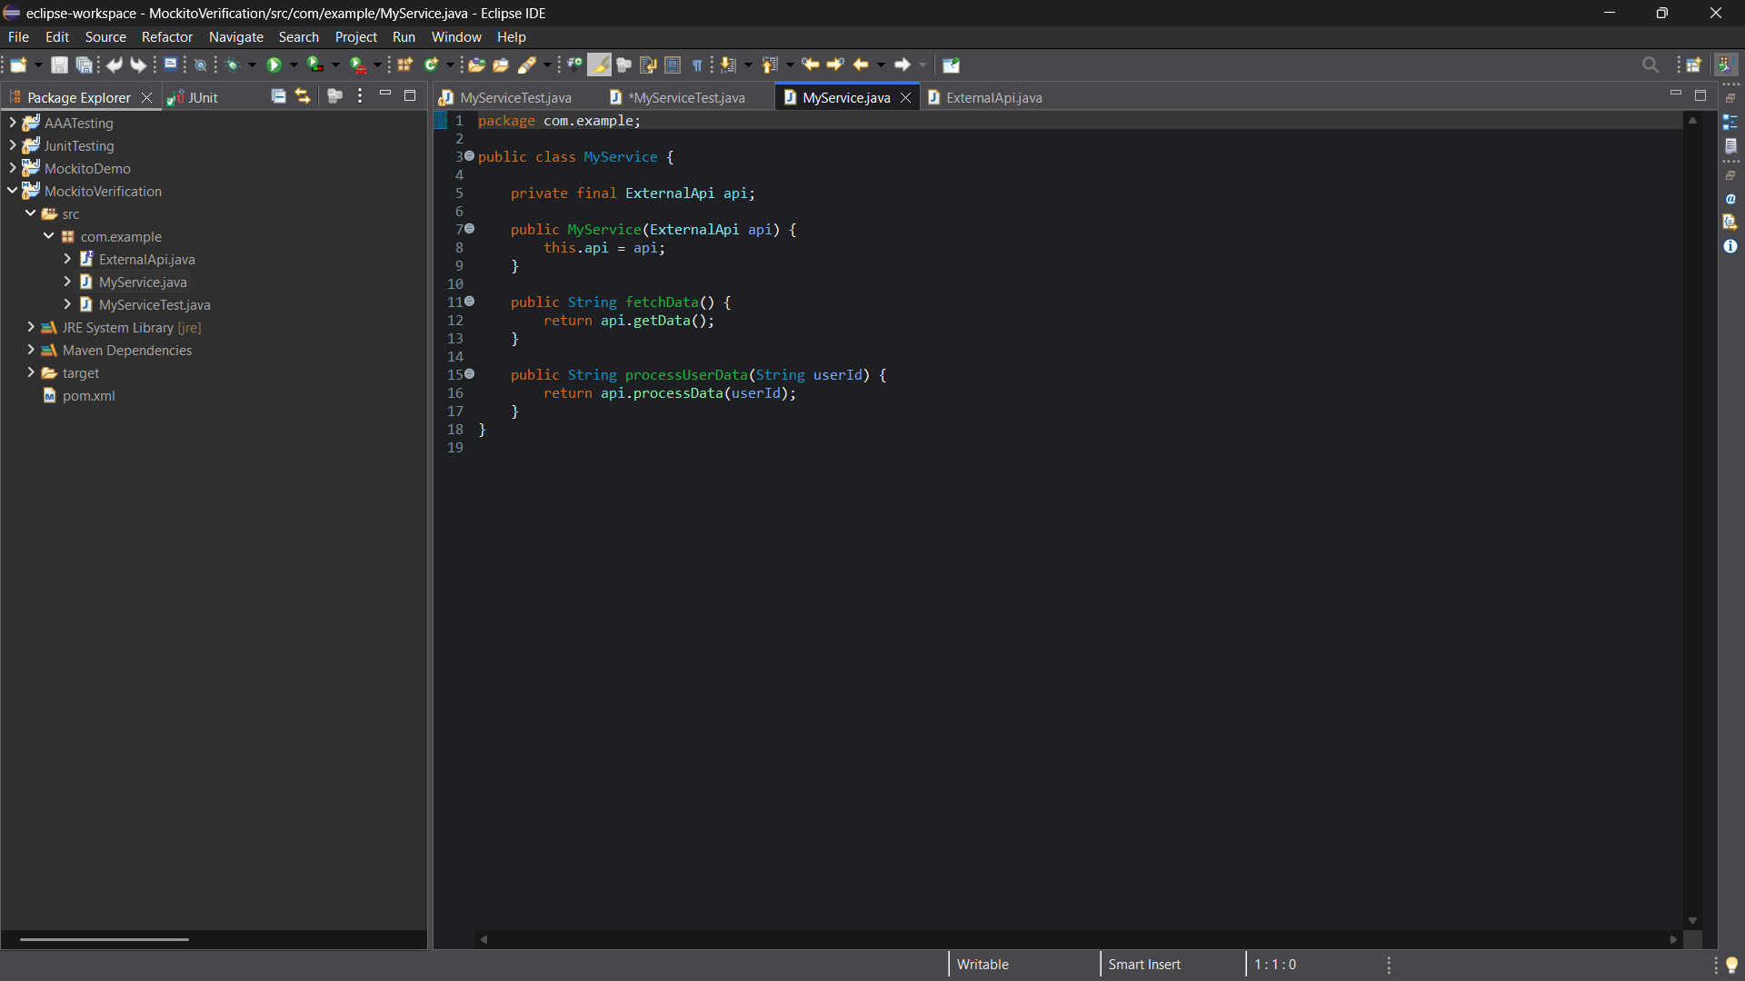

MyServiceTest.java:
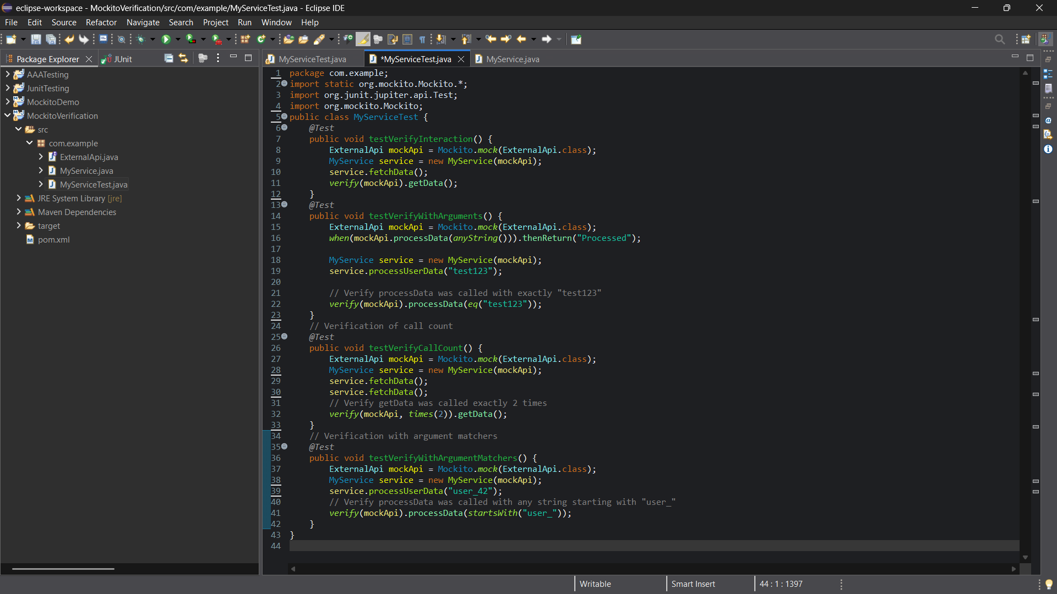
Output:
